**Problem 1**

Create a 95% confidence interval for the proportion of U.S. adults who live with one or more chronic conditions. Also interpret the confidence interval in the context of the study

Answer: (0.42648,0.47352)

It means the interval (0.42648,0.47352) that we can be 95% sure contains the population proportion.

Given : The proportion of U.S. adult report that they live with one or more chronic conditions : p=0.45

Standard error : s.=0.012

Significance level : ɑ = 1 - 0.95 = 0.05

Critical value : z $ɑ/2$ = z0.025 = 1.96

The confidence interval for population proportion is given by :- 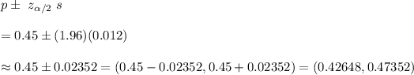

Hence, a 95% conﬁdence interval for the proportion of U.S. adults who live with one or more chronic conditions =(0.42648,0.47352)

It means the interval (0.42648,0.47352) that we can be 95% sure contains the population proportion.

**Problem 2**

a) False. Confidence periods have a number of acceptable meanings and the irony is often overlooked. A confidence level of 95 per cent "misses" around 5 percent of the time.

b)True. Remember the true population significance of the definition.

c)True. If we examine the 95% confidence interval computed in [Exercise 5.5.7](https://spot.pcc.edu/~evega/section-29.html), we can see that 50% is not included in this interval. This means that in a hypothesis test, we would reject the null hypothesis that the proportion is 0.5.

d)False. The standard error describes the uncertainty in the overall estimate from natural fluctuations due to randomness, not the uncertainty corresponding to individuals' responses.

Thank you

Student ID : 201923250

Name : Kobilov Ilkhomjon